INFORMATION
MISUSED!


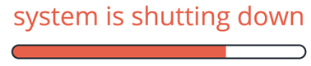




Violation of Privacy
Privacy is one’s right to keep information about oneself from others.
Today we can use various forms of technology to produce and share information on anything and everything.
Unfortunately there are technology users who misuse the technology for wrong purposes; it is either illegal or unacceptable to do so.

Propaganda
Propaganda could be defined as information, ideas or rumors deliberately spread to help or harm a person, group or movement.
It is literally defined as information of a biased or misleading nature used to promote a political cause or point of view Simply put, propaganda is anything meant to convince you to feel or act a certain way.
For example have you ever seen or heard a commercial that convinced you to: Buy a product- Propaganda! Use a service- Propaganda! Feel a certain way- Propaganda!
Propaganda and advertising really go hand in hand.
Propaganda deals with opinion expressed over media to promote pov or political cause.
With propaganda they don’t give you the truth, but misleading facts to convince you to believe what they believe.

software privacy
Software privacy is the seclusion of your software from other tech users. It refers to the copying or use of computer software in violation of its license.
The violation of someone’s software privacy is termed software piracy.

COMPUTER FRAUD
Computer fraud is the act of using electronic devices to steal or alter data to gain unlawful or illegal use of a device or system.

Canadian university loses $9.2 million to computer bank fraud
Elizabeth Weise, USATODAYPublished 12:59 p.m. ET Sept. 1, 2017 | Updated 1:00 p.m. ET Sept. 1, 2017

(Photo: MacEwan University)
CONNECTTWEET 86LINKEDINCOMMENTEMAILMORE
SAN FRANCISCO — A Canadian university has lost $9.2 million in a computer fraud case that started with a phishing attack.
It began with a series of fraudulent emails that convinced staff at MacEwan University in Edmonton, Alberta, to change electronic banking information for one of the university’s major vendors. The fraud caused the university to transfer $9.2 million ($11.8 Canadian dollars) to a bank account that staff thought belonged to the vendor but actually didn’t. The money has been traced to accounts in Canada and Hong Kong. The funds have been frozen and the university is now working with legal counsel in Montreal, London and Hong Kong to pursue civil action to recover the money, the university said in a statement. The status of the funds was unknown as of Friday, MacEwan University said. University spokesman David Beharry said the school, which has 20,000 students, wants to assure them and staff that no IT systems were compromised in the attack.“Personal and financial information, and all transactions made with the university are secure. We also want to emphasize that we are working to ensure that this incident will not impact our academic or business operations in any way,” he said. The university has instituted an audit of its business processes and put controls into place to prevent further incidents. A preliminary audit found that “controls around the process of changing vendor banking information were inadequate, and that a number of opportunities to identify the fraud were missed,” according to the university.

Industrial espionage
Industrial espionage is the covert and sometimes illegal practice of investigating competitors to gain a business advantage. The target of investigation might be a trade secret such as a proprietary product specification or formula, or information about business plans. In many cases, industrial spies are simply seeking any data that their organization can exploit to its advantage. An industrial spy may be an insider threat, such as an individual who has gained employment with the company with the purpose of spying or a disgruntled employee who trades information for personal gain or revenge. Spies may also infiltrate through social engineering tactics, for example by tricking an employee into divulging privileged information.
Spies sometimes physically breach the target organization and investigate the premises.
Infamous case of Industrial Espionage:
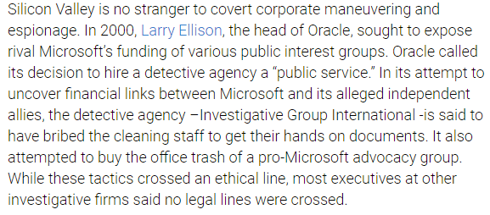

THE END
DONE BY – ANGELINA MOHAN

